Lesson 05: Gospel Call
The meaning of “gospel”
___________________________________________________________________________________
___________________________________________________________________________________
___________________________________________________________________________________
Bible Study: Romans 10:13-15
1. Who will be saved? ____________________________________________________
___________________________________________________________________________________
___________________________________________________________________________________
2. What will a person have to do if they are to call on God? ___________________
3. What will a person have to do if they are to believe? _______________________
4. What will a person have to do if they are to hear the gospel?_____________________
5. What will a person have to do if they are to preach? ___________________________
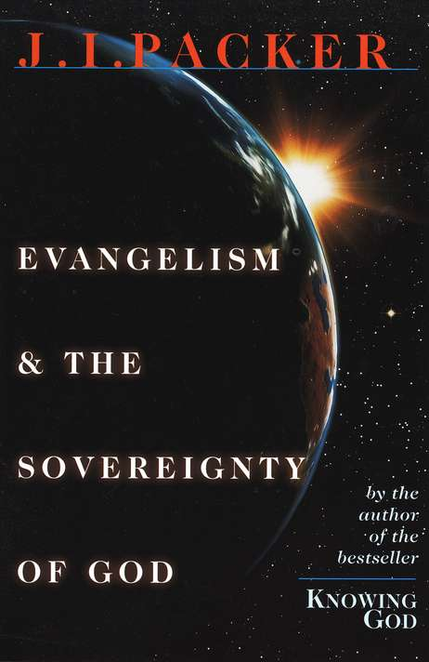
Why bother?
Why do evangelism (preach the gospel) if God has predetermined who will be saved and will Himself make sure they will be saved?
________________________________________________________
________________________________________________________
________________________________________________________
________________________________________________________
________________________________________________________
________________________________________________________
________________________________________________________
________________________________________________________
________________________________________________________
Space for further notes
___________________________________________________________________________________
___________________________________________________________________________________
___________________________________________________________________________________
___________________________________________________________________________________
___________________________________________________________________________________
___________________________________________________________________________________
___________________________________________________________________________________
___________________________________________________________________________________
___________________________________________________________________________________
___________________________________________________________________________________
___________________________________________________________________________________
___________________________________________________________________________________
___________________________________________________________________________________
Does God mean it?
___________________________________________________________________________________
___________________________________________________________________________________
___________________________________________________________________________________
___________________________________________________________________________________
___________________________________________________________________________________
___________________________________________________________________________________
___________________________________________________________________________________
___________________________________________________________________________________
___________________________________________________________________________________
More space for further notes
___________________________________________________________________________________
___________________________________________________________________________________
___________________________________________________________________________________
___________________________________________________________________________________
___________________________________________________________________________________
___________________________________________________________________________________
___________________________________________________________________________________
___________________________________________________________________________________
___________________________________________________________________________________
___________________________________________________________________________________
___________________________________________________________________________________
___________________________________________________________________________________
___________________________________________________________________________________
___________________________________________________________________________________
___________________________________________________________________________________
___________________________________________________________________________________
___________________________________________________________________________________
___________________________________________________________________________________

